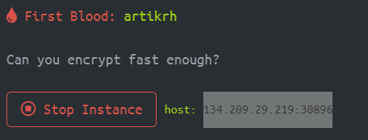

Immediately I started to use MD5 encryption form web application and I got:

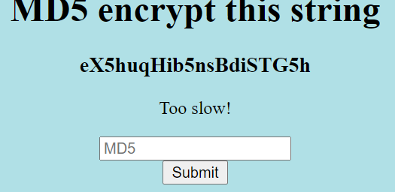

So I created python script to open session and gets the string and post the encrypted script immediately.

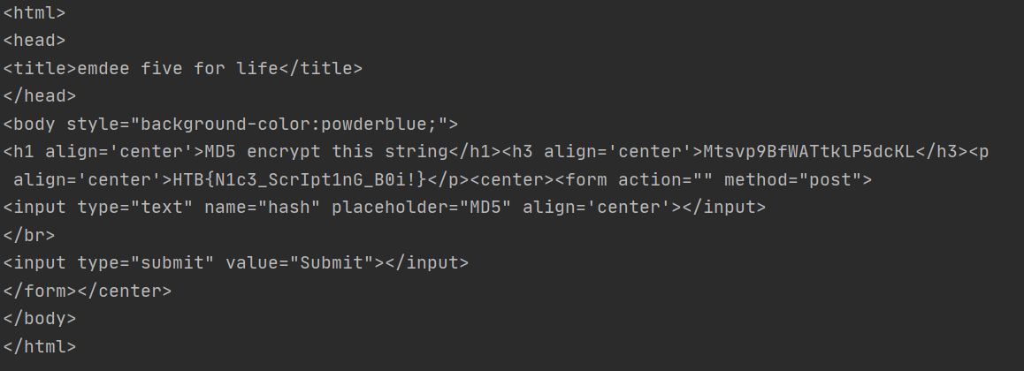

Flag: HTB{N1c3_ScrIpt1nG_B0i!}